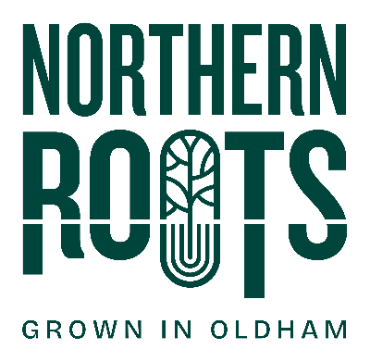
Northern Roots Volunteering:
Expression of Interest Form

Volunteer Role Title: | Urban Farm & Environmental Volunteer - Ongoing

My details:
First Name
Last Name
Email
Telephone
Address
Town
Postcode
Date of Birth
I confirm:
I am over 18
I am legally entitled to volunteer in the UK

My interest in this role
I am interested in volunteering because:

I have considered the role requirements and have the following skills / experience to offer:

I have considered what the role will involve and am interested in developing the following skills / knowledge:

My availability
I confirm I am available for volunteering the hours specified (Thursday 10am – 2pm) on an ongoing basis. We appreciate you may not be able to attend every Thursday.

Please note, if your application is accepted, we will invite you to start on a Thursday and it is important you attend the first session to have your initial induction. We will arrange a Thursday that works for you. Afterwards, you can attend any Thursday as you wish.

Please tell us if you have any access requirements or health conditions that we should know about:

Please note: volunteers will be working on different parts of the 160-acre Northern Roots site and may not have regular toilet access on some occasions. Ground conditions vary across the site and volunteers may work in areas where the ground is uneven.
Have you been a participant of our Natural Health Service, or have come to Northern Roots through Turning Point, Get Oldham Working or Hill Top Surgery? If yes, please state which service you were a part of:

Staying in touch
If accepted to the volunteering programme, would you like to be added to our Whatsapp community group?

Only admins (Northern Roots staff) can post in this Whatsapp, and your phone number will be private.
Yes, that’s fine

Your interest and support are valuable to us. We would like to use the information you have given us to let you know about other volunteering opportunities or events that may interest you via our newsletter.
Yes, that’s fine
Please note, we will never pass on your details to another organisation.
My preferred method of contact Phone Email

By post to: | Northern Roots Volunteering,  Alexandra Park Offices  Alexandra Park Depot  Kings Road  Oldham  OL8 2BH
By email to: | info@northern-roots.uk

Thank you for your interest in Northern Roots volunteering - we will be in touch soon.

