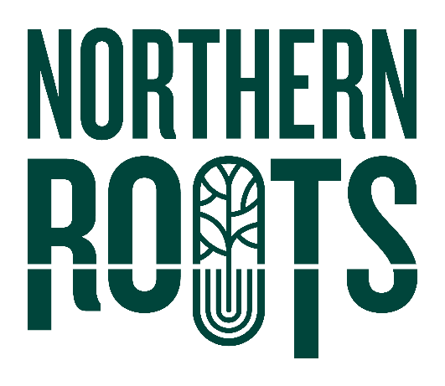Northern Roots Business

Enterprise: Expression of Interest Form – Urban Farm

**DEADLINE: Midnight, Friday 3rd October 2025**

**Your details:**

|  |  |
| --- | --- |
| Name |  |
| Email |  |
| Telephone |  |
| Address & postcode |  |
| I confirm:  I am over 18 🞏  I am legally entitled to work in the UK 🞏 | |

**Brief overview of your business idea**

|  |
| --- |
| What would you like to do at or with Northern Roots? Give us a brief snapshot of your business idea. |
| What produce do you want to grow?  What products do you want to make? |
| How much time would you dedicate to this enterprise? How many days a week would you be on site at Northern Roots? |
| What added value activities/workshops would you be able to offer? |
| Who is your customer group or target market? |
| What stage is your business at – prestart or trading?  If your business is established, how long have you been trading?  If this is a new business idea, when is your anticipated start date? |
| What support or resources would you need or welcome from Northern Roots? |
| What sort of farming network do you imagine working within? |

**Staying in touch**

|  |
| --- |
| Your interest and support are valuable to us. We would like to use the information you have given us to let you know about other opportunities or events that may interest you.  Yes, that’s fine 🞏  Please note, we will never pass on your details to another organisation. |
| My preferred method of contact Phone 🞏 Email 🞏 |

**Once you have completed this short form, please send to:**

|  |  |
| --- | --- |
| **By post to**: | Northern Roots  Alexandra Park Offices  Alexandra Park Depot  Kings Road  Oldham  OL8 2BH |
| **By email to:** | [info@northern-roots.uk](mailto:info@northern-roots.uk) |

**Thank you for your interest in Northern Roots - we will be in touch soon.**