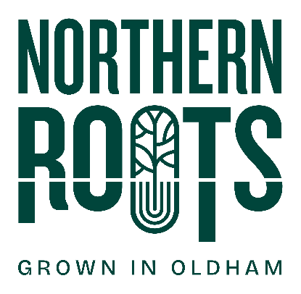
Northern Roots Takeover
Expression of Interest Form

My details:
Organisation (if applicable)
First Name
Last Name
Email
Telephone
Address
Postcode
Link to your website / portfolio if applicable
I confirm:
I am over 18
I am legally entitled to work in the UK

Takeover Proposal (limit to 1000 words)
Tell us about yourself and/or your organisation. What experience do you have of producing events/ workshops/other? What skills do you offer? What are you passionate about? (200 words)

What idea would you like to deliver at Northern Roots? (200 words)

Who is your idea for? Who is your audience? i.e. mums and babies, young people, men etc. (200 words) Why will they enjoy it?

How will your idea involve local communities? (200 words)

How will you use the £500? Please give a clear breakdown of your costings. Please bear in mind, this is £500 including VAT.

We are looking to support two Takeovers at Northern Roots between July and October 2025. If successful, when would you like to deliver your idea?

What assistance would you require from the Northern Roots Creative Producer? (200 words)

Please return this form by the end of the day on Sunday 6th July 2025.

By post to: | Northern Roots  Alexandra Park Offices  Alexandra Park Depot  Kings Road  Oldham  OL8 2BH
By email to: | info@northern-roots.uk

Thank you for your interest in this opportunity - we will be in touch soon.

