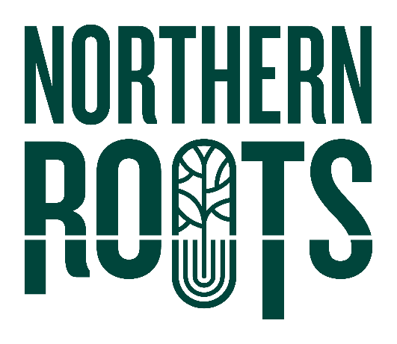Northern Roots Business

Enterprise: Expression of Interest Form

**Your details:**

|  |  |
| --- | --- |
| Name |  |
| Email |  |
| Telephone |  |
| Address |  |
| Postcode |  |
| I confirm:  I am over 18 🞏  I am legally entitled to work in the UK 🞏 | |

**Brief overview of your business idea**

|  |
| --- |
| What is your business sector? |
| What would you like to do at or with Northern Roots? Give us a brief snapshot of your business enterprise idea. |
| How does your business proposal align with Northern Roots core objectives? |
| Who is your customer group or target market? |
| What stage is your business at – prestart or trading? |
| What is your anticipated start date OR how long have you been trading? |

**Staying in touch**

|  |
| --- |
| Your interest and support are valuable to us. We would like to use the information you have given us to let you know about other opportunities or events that may interest you.  Yes, that’s fine 🞏  Please note, we will never pass on your details to another organisation. |
| My preferred method of contact Phone 🞏 Email 🞏 |

**Once you have completed this short form, please send to:**

|  |  |
| --- | --- |
| **By post to**: | Northern Roots  Alexandra Park Offices  Alexandra Park Depot  Kings Road  Oldham  OL8 2BH |
| **By email to:** | [info@northern-roots.uk](mailto:info@northern-roots.uk) |

**Thank you for your interest in Northern Roots - we will be in touch soon.**