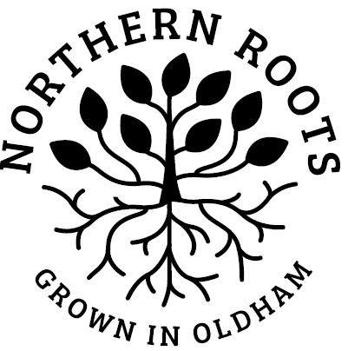
Northern Roots Volunteering: Expression of Interest Form

Volunteer Role Title: | Urban Farm & Environmental Volunteer, Northern Roots

My details:
First Name
Last Name
Email
Telephone
Address
Town
Postcode
Date of Birth
I confirm:
I am over 18
I am legally entitled to volunteer in the UK

My interest in this role
I am interested in volunteering because:

I have considered the role requirements and have the following skills / experience to offer:

I have considered what the role will involve and am interested in developing the following skills / knowledge:

My availability
I confirm I am available for volunteering the hours specified and for the full duration of the volunteering programme specified in the Volunteer Role Description
Please tell us if you have any access requirements or health conditions that we should know about:

Please note: volunteers will be working on different parts of the 160-acre Northern Roots site and may not have regular toilet access on some occasions. Ground conditions vary across the site and volunteers may work in areas where the ground is uneven.

Staying in touch
Your interest and support are valuable to us. We would like to use the information you have given us to let you know about other volunteering opportunities or events that may interest you.
Yes, that’s fine
Please note, we will never pass on your details to another organisation.
My preferred method of contact Phone Email

Please return this form to Northern Roots by 10am on Wednesday 25th January 2023.

By post to: | Northern Roots Volunteering,  Alexandra Park Offices  Alexandra Park Depot  Kings Road  Oldham  OL8 2BH
By email to: | info@northern-roots.uk

Thank you for your interest in Northern Roots volunteering - we will be in touch soon.

