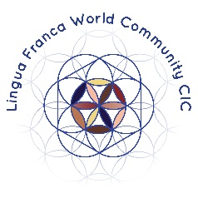
LINGUA FRANCA WORLD COMMUNITY CIC & NORTHERN ROOTS

10,000 Steps Around the World COMMISSION

APPLICATION FORM

Name
Address
Daytime Telephone
Email Address
Website Address
(if applicable)
Artform/Discipline

Use this box to tell us about yourself and your creative practice (200 words).

Please use the box below to write a proposal (500 words max) for a new creative project in response to Human: Nature, which could be part of Ten Thousand Steps Around the World festival at Northern Roots.

Please give us an outline budget for your proposal (including your artist fee).

Please also include links to your existing work.

