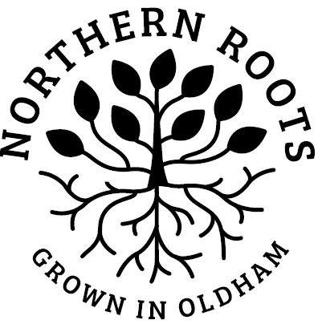
Northern Roots Community Champions: Expression of Interest Form

Role Title: | Community Champion, Northern Roots

My details:
First Name
Last Name
Email
Telephone
Address
Town
Postcode
I confirm:
I am over 18
I am legally entitled to work in the UK

My interest in this role
I am interested in becoming a Community Champion because:

I have considered the role requirements and have the following skills / experience to offer:

I have considered what the role will involve and am interested in developing the following skills / knowledge:

Please tell us if you have any access requirements or health conditions that we should know about:

Please return this form by midnight on Sunday 5th December October 2021.

By post to: | Northern Roots  Alexandra Park Offices  Alexandra Park Depot  Kings Road  Oldham  OL8 2BH
By email to: | northern.roots@oldham.gov.uk

Thank you for your interest in Northern Roots - we will be in touch soon.

