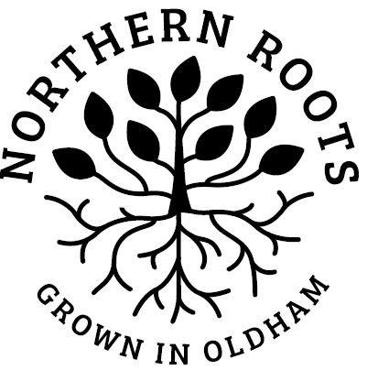
Northern Roots

Job Title: | Arts & Culture Producer, Northern Roots

My details:
First Name
Last Name
Email
Telephone
Address
Town
Postcode
I confirm:
I am over 18
I am legally entitled to work in the UK

Based on the Job Description and Person Specification, tell us why you’re suitable for this role (no more than 2 sides of A4).

Pitch one idea to us (one side of A4 maximum).

Your brief is to design and produce a project that results in a creative event taking place on the Northern Roots site. The project must involve twenty local young people and give them the opportunity to build skills, creativity and confidence.

Additionally, the project must have a digital element, attract 2000 people to the Northern Roots site but be sensitive to the environment and the landscape, in keeping with Northern Roots over-arching ethos. How would you approach this?

Pitch one idea in no more than one side of A4. We’re looking for a sense of your creativity and innovation - your idea does not have to be fully worked up. Please provide an indicative budget.

Specific Arrangements
Please tell us if there are any reasonable adjustments we can make to assist you in your application or with our recruitment process?

Notice Period
If offered the job, how much notice would you need to provide to your current employer?

References
Please give the names and addresses of two people from whom references can be requested. Please indicate the capacity in which they know you. One referee must be your present or last employer. We will not contact your referees without your permission
Name
Address
Telephone No.
Email address
Relationship to you

Name
Address
Telephone No.
Email address
Relationship to you

Declaration
I confirm that to the best of my knowledge the information given on this form is true and correct and can be treated as part of any subsequent Contract of Employment.
Signed (print if via email):
Date:

Please submit this form by midnight on Tuesday 30th November 2021 along with your current CV and the Equal Opportunities form.

The information from the Equal Opportunities form enables us to monitor the effectiveness of our equal opportunities practice and to ensure that we are open to all. Any information that you provide is confidential and will be kept separate from your application form.
Please note that all applications received after the closing date, midnight Tuesday 30th November, will be automatically rejected as standard practice and without exception, in the interests of fairness.
Shortlisted applicants will be invited to attend an interview in the week beginning 6th December.

By post to: | Justine Race, Northern Roots  Alexandra Park Offices  Alexandra Park Depot  Kings Road  Oldham  OL8 2BH
By email to: | northern.roots@oldham.gov.uk

Thank you for your interest in Northern Roots - we will be in touch soon.

