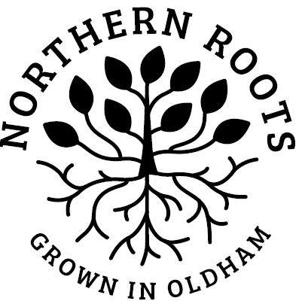
Northern Roots Volunteer Role 003

Environmental
Volunteer
Role description
Volunteer role title | Environmental Volunteer
Where this role will take place | Northern Roots,  Off Kings Road,  Oldham  OL8 2BH
Overview of role | This is a new opportunity to join an 8-week volunteer programme, supporting the Northern Roots team to improve access, signage and pathways, and develop new habitats for wildlife.  If you love being outdoors, practical work and want to improve the natural environment, this could be for you.  Northern Roots is creating the UK’s largest urban farm and eco-park on 160-acres, ten minutes from Oldham town centre.  The Northern Roots site stretches from Alexandra Park at the northern end of the site, past Park Bridge, to Bankfield Clough at the southern end of the site.
What the role will involve | An 8-week programme of environmental improvements focusing on:  - Woodland clearance  - Creating deadwood habitats  - Vegetation clearance to improve path access  - Seed collecting  - Litter picking
Volunteer hours for this role | The volunteer hours for this role are:  2 hours per week, Thursdays 10.00am - 12.00pm for 8 weeks, starting Thursday 28th October, finishing Thursday 16th December 2021
Key Contact | Alan Price, Landscape Manager, Northern Roots
Role requirements
Training / qualifications: | No requirements
Skills and experience: | Essential – none  Desirable – none, however any previous volunteering experience and any environmental, woodland management or path maintenance skills will be an asset
Personal qualities: | - Enthusiasm in working outdoors  - Enjoy practical tasks  - Interest in the natural world  - ‘I can’ attitude
Other | Priority will be given to volunteers who live locally to the Northern Roots site.
What you will gain from the role | - Skills in woodland management, path and route maintenance, habitat creation  - Life skills - team working, communication, problem solving, self-confidence and personal management  - Meet new people, develop friendships  - Satisfaction in the impact your contribution has made as part of a collective effort  - Opportunity for further volunteering  - Kudos - being part of the Northern Roots project working for:  - environmental change  - bio-diversity in Oldham  - bringing people together
Thank you for considering a volunteering role with Northern Roots, Oldham

