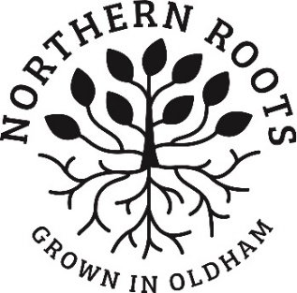
Equal Opportunities Monitoring Form

We are committed to equal opportunities in our recruitment. The information collected in this form helps us monitor the diversity of applicants that we attract. This form is voluntary but the information we collect here is very useful to us in improving the effectiveness of our recruitment. The information you provide will be kept confidentially and will be used only for equal opportunities monitoring purposes. This monitoring form will be separated from your application form before short listing takes place.
Post Applied for:
Surname:
First name:
How did you find out about the post?
 | Northern Roots website |  | Charity Jobs
 | Other online Job Board |  | Northern Roots staff referral
 | Recruitment agency |  | Facebook
 | OMBC staff referral |  | Twitter
 | LinkedIn |  | Other social media channel
 | Other |  | Internal applicant already working for Northern Roots

Birth year and Gender
Year of Birth |  |  | Gender at Birth

Is your gender the same now as it was at birth?

How would you describe your sexual orientation?
 | Straight (Heterosexual) |  | Gay (Homosexual)
 | Lesbian (Homosexual) |  | Bisexual
 | Other (please specify) __________________________________________________________

Your Nationality?
___________________________________________

Your Ethnicity? Please check the box that best describes you.
Asian or Asian British – Indian  Asian or Asian British – Bangladeshi  Asian or Asian British – Kashmiri  Black or Black British – Caribbean  Black or Black British - Any other Black background  Mixed - White and Black African  Mixed – Any other mixed background  White – Irish  White - Eastern European  Other ethnic group – Arab  Other ethnic group – Latin America  Other _________________________ | Asian or Asian British – Pakistani  Asian or Asian British – Chinese  Asian or Asian British - Any other Asian background  Black or Black British – African  Mixed - White and Black Caribbean  Mixed - White and Asian  White - English/Welsh/Scottish/Northern Irish/British  White - Gypsy or Irish Traveller  White - Any other White background  Other ethnic group- Roma  Other ethnic – Kurdish

Disability: Do you consider yourself to be disabled?
The Equality Act 2010 defines a disabled person as someone who has a physical or mental impairment which has a substantial and long-term adverse effect on their ability to carry out normal day-to-day activities.
 | Yes |  | No

Thank you for completing this form. Best wishes with your application!

