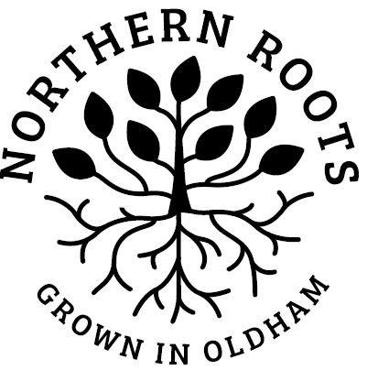
Community Food
Growing Volunteer
Northern Roots, Snipe Clough, Oldham
Role description

Would you like to join our friendly volunteer team in the new year and help grow food for local communities in need? Northern Roots has teamed up with Alexandra Park Growing Hub to create a new growing project on the Northern Roots site, which will grow fresh veg for communities across Oldham.

Gardening has been proven to have therapeutic benefits, helping alleviate isolation and improve wellbeing, though gentle exercise, getting outside, growing plants and social interaction. The role will help you to develop skills in gardening and food growing. You get to work outdoors, grow some great tasting fruit and veg and meet new people. You could make a real difference to the lives of vulnerable and isolated people as well as enjoying a share of the fresh produce and the satisfaction of collaborative working.

Main duties
The focus of this role is to assist in creating and establishing market garden style vegetable beds to grow fresh produce that will be distributed within the Oldham community to those in need. In addition to creating the growing beds, activities will include; seed sowing and planting, vegetable care and maintenance and more. The activities will vary from season to season but will be outside.

Please note that in bad weather, there is no shelter on site, so you need to be happy working in all weathers. Sessions may be cancelled in bad weather. Gardening or allotment experience would be a benefit, but not essential.
Volunteers in this role, at times, will be expected to be able to work independently, with limited supervision.

This role will run from January – March 2021. We are specifically looking for people who enjoy working outdoors, digging and barrowing. We will be grateful for your help in getting the growing beds ready for the growing season.

Weekly Volunteer Session Times: Tuesdays 1-3pm and / or Thursdays 10-12pm. If interested in volunteering, please contact Hannah to find out about availability.

COVID-19 considerations:
We are committed to providing a safe volunteering environment. Our sessions have been risk assessed for Covid-19 safety.

You will be asked to provide your contact details and observe current Covid 19 guidelines.

Due to the current restrictions, to maintain social distancing there will be limited access to The Hub facilities. At this time, we are unable to offer drinks. You are welcome to bring your own. Toilet facilities are available in the park.

If interested
If interested, please contact Hannah Williams to find out which sessions have availability and to chat about the role. Before volunteering we will ask you to come for an induction and complete a registration form.
Contact: hannah.williams@oldham.gov.uk

