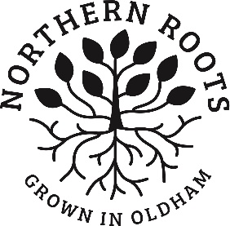
Northern Roots Creative Writing Competition Application Form
Please submit your signed and completed form to Northern.Roots@oldham.gov.uk by Monday 9th November 2020.

YOUR DETAILS

NAME
ADDRESS
PHONE NUMBER (parent/guardian if under 18)
EMAIL (parent/guardian if under 18)
CATEGORY YOU ARE SUBMITTING TO?

AGE IF UNDER 18?

HAVE YOU READ THE COMPETITION RULES?

DO YOU LIVE, WORK OR STUDY IN OLDHAM?
HAVE YOU VISITED THE NORTHERN ROOTS SITE? | If you have visited the site, tell us briefly what you think of it? Did anything surprise you?
NORTHERN ROOTS PROJECT | What do you think about the Northern Roots project? What excites or interests you most? What would you really like to see happening?

your entry – please insert your entry here

In order to offer the Northern Roots Creative Writing Competition opportunity to you, it is necessary for Northern Roots to collect and hold some personal information about competition participants. We will only keep your information for the minimum period necessary. We treat and manage your data with care and privacy and every member of staff, including volunteers comply with data protection guidelines. You can withdraw from the competition and/or request your data to be removed from our files at any time by emailing northern.roots@oldham.gov.uk You can find the Northern Roots Creative Writing Competition Privacy Notice, along with the Northern Roots Creative Writing Competition Rules & FAQS on the Northern Roots Creative Writing Competition web page.

Signature

Signed___________________________________ Date_____________________
PRINT NAME ____________________

Signed by parent/guardian_______________________ Date_____________________
PRINT NAME ____________________

THANK YOU!

