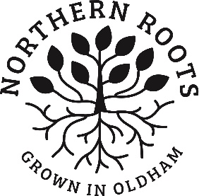
Northern Roots
Trainee Beekeeper Application Form-
Individuals

Please submit your completed form to Northern.Roots@oldham.gov.uk by Friday 26 June 2020.

INdividual DETAILS

Please give your personal details
Name
Address

Phone Number
Email
How do you currently spend your time? (eg. occupation, caring for children, training, retired, volunteering, other).
Please inform us of any access requirements, health conditions, including allergies that we should know about.
Session preference and reasons.
If you wish us to link your application to another applicant please state their full name. (Family member, work colleague etc)

Project DEtAILS

- Interests
Please explain your interest in this project, for example, what draws you to beekeeping, what interests you about learning how to care for bees? (200 words max)

- Outcomes
2.1 How will you benefit from learning how to care for bees and from participation in the project? (max 100 words)

2.2 How will your participation in the project potentially benefit the communities you live in or connect with? (this may be a community of place, interest, or similar affiliation)
(max 100 words)

2.3 How will you ensure you gain the most from this training opportunity? What are your plans and goals on completion of this training? (Max 200 words)

References

References
Please detail 2 references that we can contact to confirm your suitability for this training programme. Please include at least one person that knows you in a professional manner, for example a previous employer, or an educator. Please do not include family members or close friends as references.
Name:
Email address:* Telephone:
Connection to you:

Name:
Email address:* Telephone:
Connection to you:
*We prefer email address for speed, however please include a postal address if there is no email.

Confirmation Of Commitment

- Signatures
Your signature below confirms you are committed to investing a minimum of 3 hours a week on average in your training for the project duration.

Signed___________________________________ Date_____________________

PLEASE RETURN THIS FORM BY FRIDAY 26 JUNE 2020.

BY POST:

Northern roots, ALEXANDRA PARK OFFICES, ALEXANDRA PARK DEPOT, KINGS ROAD, OLDHAM, OL8 2BH

BY EMAIL:

northern.roots@OLDHAM.GOV.UK

